- Class diagram to model for The Project Management Tracking System
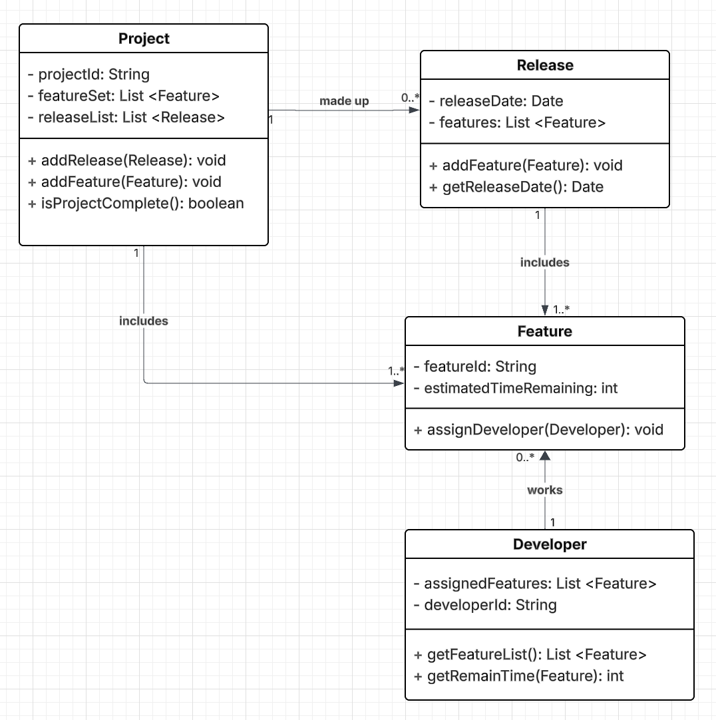

- Prob 2A: https://github.com/miunthphuong/MPP/tree/main/Assigment/Lab2/prob2a/src
Prob 2B: https://github.com/miunthphuong/MPP/tree/main/Assigment/Lab2/prob2b/src

- Class diagrams:
  - Position Hierarchy

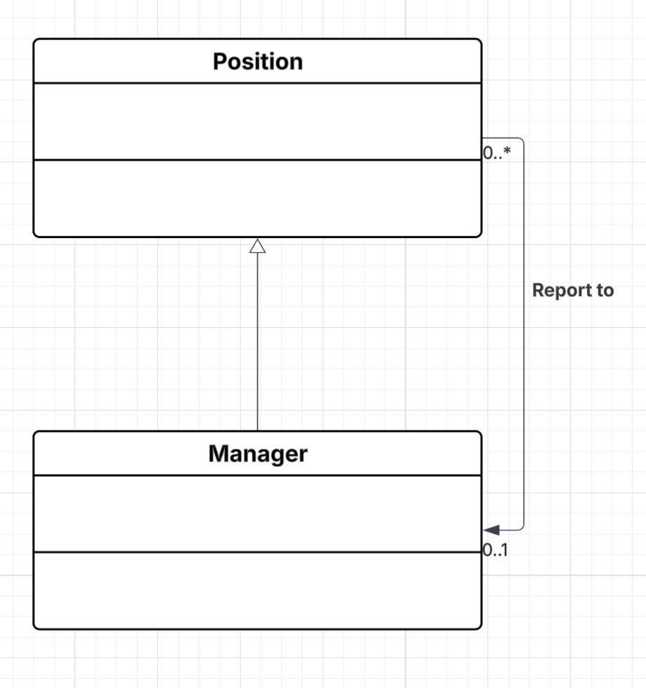

  - Course Prerequisites

